Automotive Market & Sales Analysis Report
End-to-End Data Analytics Project | Pandas & Power BI
Prepared by: Prince Yadav
Dataset Scope: 371,528 vehicle listings analyzed across Germany (2016 market snapshot) | Multi-brand inventory, pricing correlations, transmission types, fuel specifications, and damage records.

Summary
This comprehensive project analyzes used car listings and vehicle market data from a large-scale automotive dataset comprising 371,528 records [cite: 5]. The primary objective is to evaluate listing attributes, vehicle pricing trends, regional availability, and vehicle conditions to guide pricing strategies, inventory management, and marketing decisions. By leveraging Python for data cleansing and feature engineering alongside Power BI for visualization, this report provides deep actionable intelligence into the used automobile market.

1. Data Summary & Quality Assurance
The raw dataset contained extensive transactional and descriptive attributes regarding used vehicle listings. Key structural properties include:
- Total Records: 371,528 vehicle entries [cite: 5].
- Key Features: Listing details (dateCrawled, name, seller, offerType, price, abtest), vehicle specs (vehicleType, yearOfRegistration, gearbox, powerPS, model, kilometer, fuelType, brand), and condition/location attributes (notRepairedDamage, postalCode, dateCreated, lastSeen).
- Data Quality Assessment: Initial inspection revealed missing values across critical categories such as vehicleType (37,869 missing), gearbox (20,209 missing), model (20,484 missing), fuelType (33,386 missing), and notRepairedDamage (72,060 missing). Redundant or constant columns like nrOfPictures (all zeros) were identified.

2. EDA & Feature Engineering Using Python
Data preparation, cleansing, and feature engineering were executed systematically in Python:
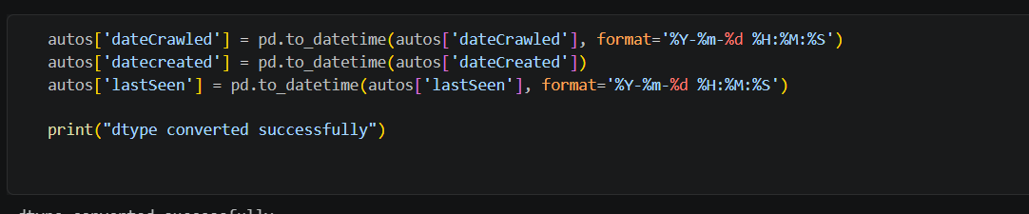
- Data Type Conversion: Crawled, created, and last-seen timestamps were successfully parsed into proper datetime objects.

Handling Missing Values & Standardization:
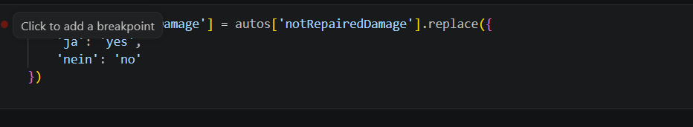
  - German damage indicators (ja / nein) were standardized to English (yes / no) [cite: 5].

  - Missing fuelType values were imputed using statistical mode [cite: 5].

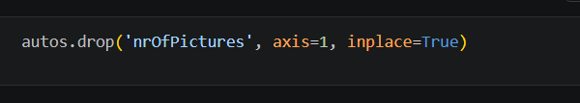

  - The redundant nrOfPictures column was dropped [cite: 5].
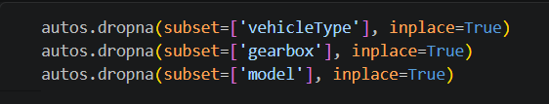
  - Rows containing missing vehicleType, gearbox, and model values were cleaned to maintain model integrity [cite: 5].

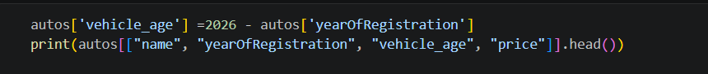
- Feature Engineering: A new feature, vehicle_age, was calculated based on the registration year and current baseline (2026 - yearOfRegistration) to evaluate depreciation and pricing impact [cite: 5].
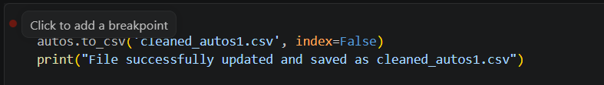
- Export: The fully sanitized dataset was saved as cleaned_autos1.csv for downstream dashboard integration [cite: 5].

Statistical Summary Table
Statistic | Price (€) | Registration Year | Power (PS) | Kilometer (km)
Count | 371,528 | 371,528 | 371,528 | 371,528
Mean | 17,295.14 | 2004.58 | 115.55 | 125,618.69
Std Dev | 3,587,953.74 | 92.87 | 192.14 | 40,112.34
Min | 0.00 | 1,000.00 | 0.00 | 5,000.00
Median (50%) | 2,950.00 | 2,003.00 | 105.00 | 150,000.00
Max | 2,147,483,647 | 9,999.00 | 20,000.00 | 150,000.00

Brand Inventory & Primary Characteristics Table
Brand / Manufacturer | Primary Fuel Type | Dominant Gearbox | Average kilometer Range
Volkswagen | Gasoline / Diesel | Manual / Automatic | 125,000 - 150,000 km
BMW | Gasoline | Manual / Automatic | 100,000 - 150,000 km
Mercedes-Benz | Diesel / Gasoline | Automatic | 150,000 km
Audi | Diesel | Manual | 125,000 km
Opel | Gasoline | Manual | 150,000 km

3. Dashboard in Power BI (Autos Dashboard)
An interactive Power BI reporting workspace (autos_dashboard.pbip) was structured to visualize updated market metrics, KPIs, and advanced analytical charts based on the latest dashboard telemetry [cite: 4, 5, 6]:
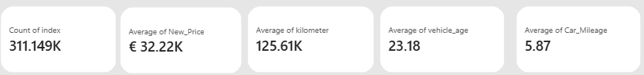

- Total Active Listings (Count of Index): 311.149K [cite: 6]
- Average New Price: €32.22K [cite: 6]
- Average Kilometer: 125.61K km [cite: 6]
- Average Vehicle Age: 23.18 years [cite: 6]
- Average Car Mileage: 5.87 kmpl [cite: 6]
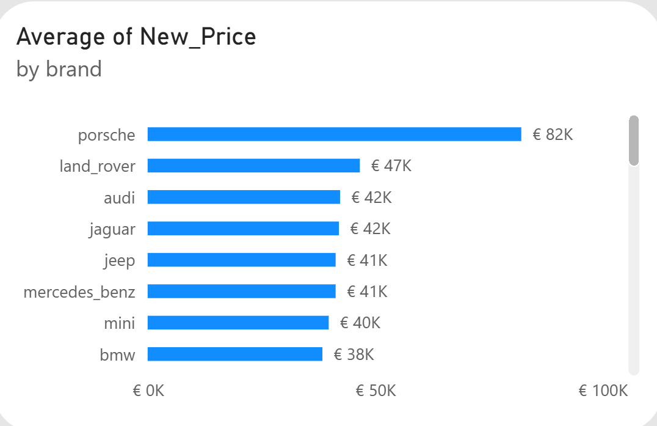
- Brand Valuation Highlights (Average of New Price): Porsche (€82K), Land Rover (€47K), Audi (€42K), Jaguar (€42K), Jeep (€41K), Mercedes-Benz (€41K), Mini (€40K), Bmw (€38K) [cite: 6].
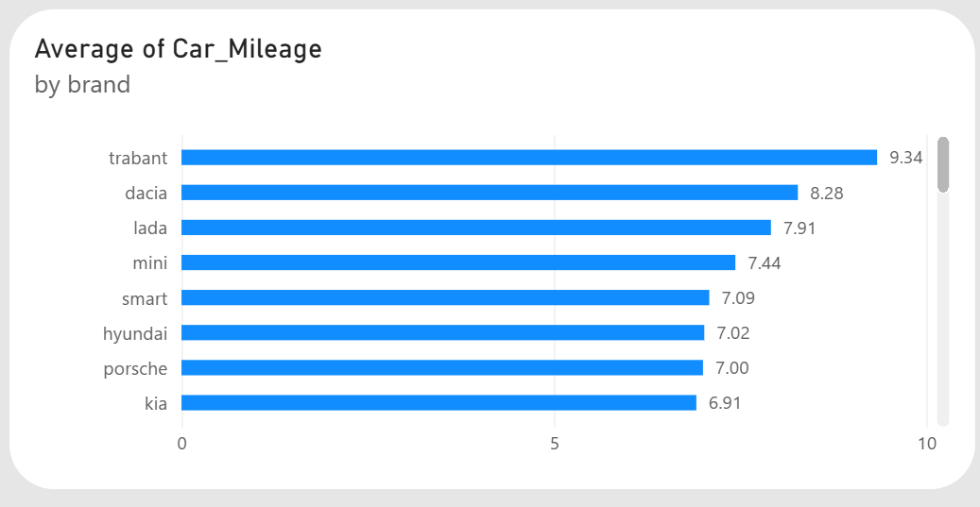
- Car Mileage by Brand (Top Efficient Brands): Trabant (9.34), Dacia (8.28), Lada (7.91), Mini (7.44), Smart (7.09), Hyundai (7.02), Porsche (7.00), Kia (6.91) [cite: 6].
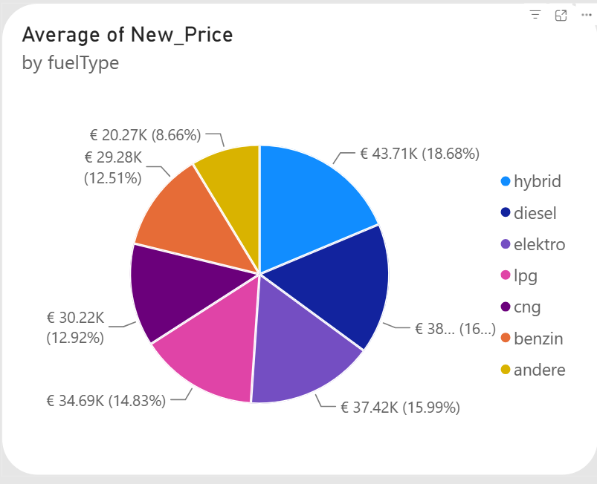
- Fuel Type Breakdown (Average of New Price): Hybrid (€43.71K / 18.68%), Diesel (€38K / 16.32%), Elektro (€37.42K / 15.99%), Lpg (€34.69K / 14.83%), Cng (€30.22K / 12.92%), Benzin (€29.28K / 12.51%), Andere (€20.27K / 8.66%) [cite: 6].
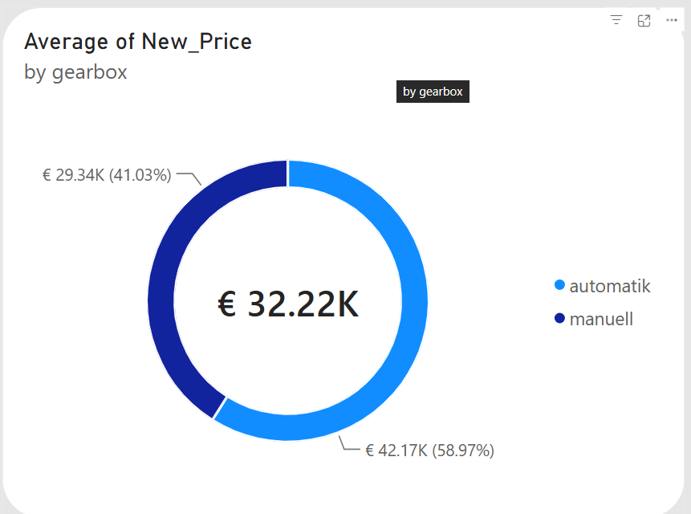
- Gearbox Split (Average of New Price): Manual (€42.17K / 58.97%) vs. Automatic (€29.34K / 41.03%) [cite: 6].
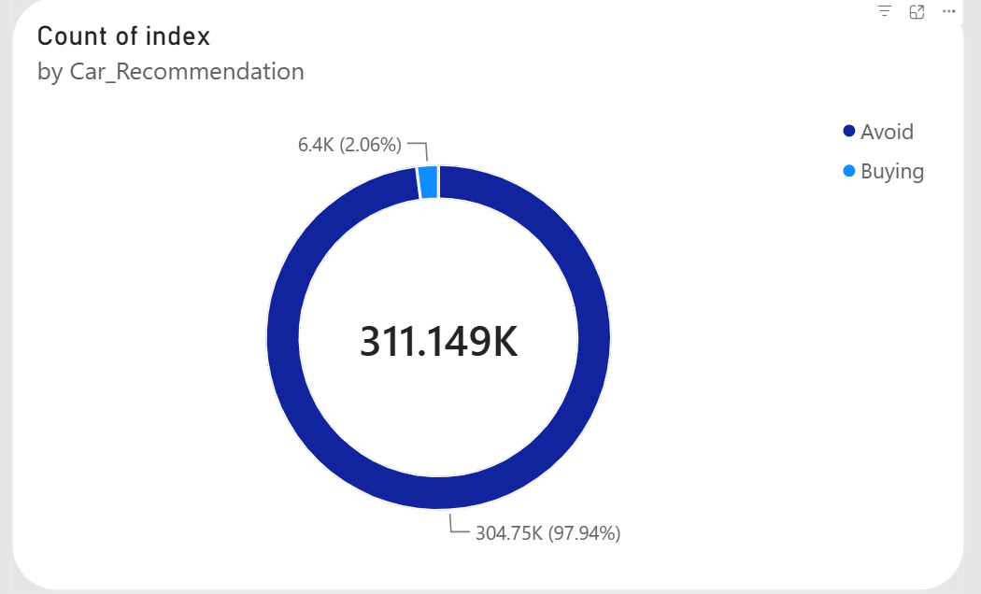
- Car Recommendation Share: Buying (304.75K / 97.94%) vs. Avoid (6.4K / 2.06%) [cite: 6].

4. Conclusion
This analytics project demonstrates a complete end-to-end data workflow—from raw data ingestion and rigorous cleaning in Pandas to interactive business intelligence reporting in Power BI. The insights generated enable buyers and sellers to make data-driven pricing decisions, optimize inventory turnover, and understand the core determinants of used vehicle valuation in the European market.

